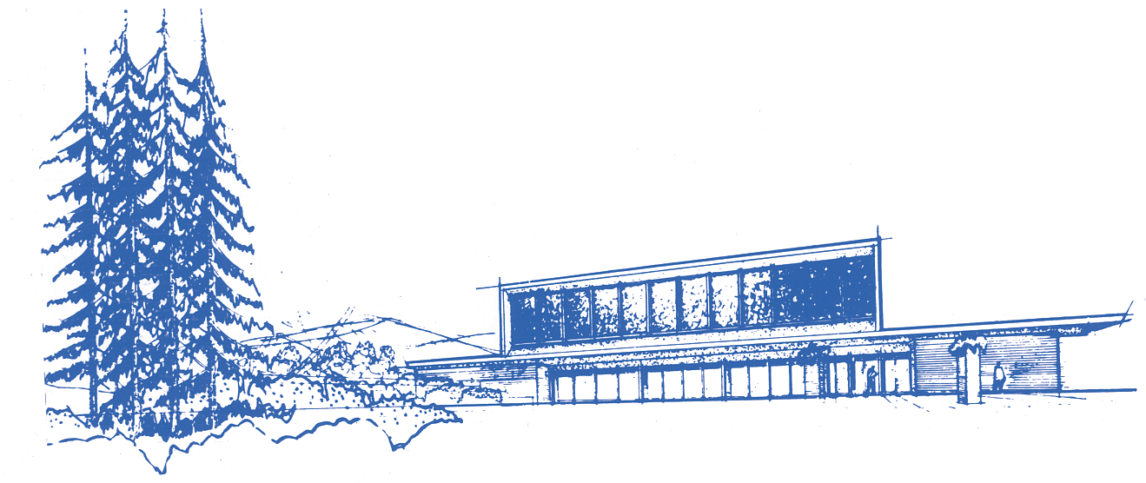
HERZL-NER TAMID CONSERVATIVE CONGREGATION
Affiliated with the United Synagogue of Conservative Judaism

Rabbi Barry Leff • Cantor Bradlee Kurland• Dr. Eliyahu Krigel

Agreement Letter of Understanding for B’nai Mitzvah Families and TGIS Friday Dinners at HNT

Date: ____________________ Student Name: ________________________

Parent Name: __________________________TGIS Date: ________________

Points of Agreement:

- There are five TGIS dinners throughout the year and the dates are 11/13/21, 12/11/21, 2/26/22, 3/26/22, and 4/30/22.

- As a b’nai mitzvah family, we understand there is a TGIS dinner on the Friday night before our students’ bar or bat mitzvah.

- Our family will join the TGIS dinner on Friday night and we agree to pay the caterer price per person for our guests and not the regular TGIS price per meal because that price is subsidized by FRS. We will provide our final guest list for Friday night two weeks prior to the Friday night dinner.

- We agree to answer emails from the HNT office in a timely manner.

- We will use the same caterer for our celebration kiddush that is used for TGIS. If we use a different caterer, we agree to coordinate kitchen times
with the TGIS caterer related to the Friday night dinner and Saturday kiddush or dinner. We understand we will not be able to set up the social hall for Saturday on Friday afternoon because TGIS is in the social on Friday night.

Thank you for your cooperation. By signing below, we agree to the above points of agreement:

__________________
Parent Name

__________________
Nadine Strauss

___________________
Dr. Eliyahu Krigel

3700 EAST MERCER WAY, P.O. Box 574, MERCER ISLAND, WASHINGTON 98040-0574 • Telephone (206) 232-8555
email: info@h-nt.org • web site: www.h-nt.org

